

**Western Australian Certificate of Education**

**ATAR course examination, 2018**

**Question/Answer Booklet**

12 PHYSICS

Name

**Test 3 - Moments and Equilibrium**

|  |  |  |  |  |  |  |  |  |  |  |
| --- | --- | --- | --- | --- | --- | --- | --- | --- | --- | --- |
| Student Number: In figures |  |  |  |  |  |  |  |  |  |  |

**Mark:**  In words

#### Time allowed for this paper

Reading time before commencing work: five minutes

Working time for paper: seventy minutes

**Materials required/recommended for this paper**

To be provided by the supervisor

This Question/Answer Booklet

Formulae and Data Booklet

***To be provided by the candidate***

Standard items: pens, (blue/black preferred), pencils (including coloured), sharpener, correction fluid/tape, eraser, ruler, highlighters

Special items: non-programmable calculators satisfying the conditions set by the School Curriculum and Standards Authority for this course

**Important note to candidates**

No other items may be taken into the examination room. It is your responsibility to ensure that you do not have any unauthorised notes or other items of a non-personal nature in the examination room. If you have any unauthorised material with you, hand it to the supervisor before reading any further.

**Structure of this paper**

|  |  |  |  |  |  |
| --- | --- | --- | --- | --- | --- |
| Section | Number of questions available | Number of questions to be answered | Suggested working time  (minutes) | Marks available | Percentage of exam |
| Section One:  Short Answers | - | - | - |  |  |
| Section Two:  Problem-solving | 11 | 11 | 70 | 55 | 100 |
| Section Three:  Comprehension | - | - | - | - | - |
|  |  |  |  | **Total** | 100 |

**Instructions to candidates**

1. The rules for the conduct of examinations at Holy Cross College are detailed in the College Examination Policy*.* Sitting this examination implies that you agree to abide by these rules.

2. Write your answers in this Question/Answer Booklet.

3. Working or reasoning should be clearly shown when calculating or estimating answers.

4. You must be careful to confine your responses to the specific questions asked and to follow any instructions that are specific to a particular question.

5. Spare pages are included at the end of this booklet. They can be used for planning your

responses and/or as additional space if required to continue an answer.

• Planning: If you use the spare pages for planning, indicate this clearly at the top of the page.

• Continuing an answer: If you need to use the space to continue an answer, indicate in the original answer space where the answer is continued, i.e. give the page number. Fill in the number of the question(s) that you are continuing to answer at the top of the page.

6. Answers to questions involving calculations should be ***evaluated and given in decimal***

***form*.** It is suggested that you quote all answers to ***three significant figures***, with the

exception of questions for which estimates are required. Despite an incorrect final result, credit may be obtained for method and working, providing these are ***clearly and legibly set out***.

7. Questions containing the instruction "estimate" may give insufficient numerical data for their solution. Students should provide appropriate figures to enable an approximate solution to be obtained. Give final answers to a maximum of two significant figures and include appropriate units where applicable.

8. Note that when an answer is a vector quantity, it must be given with magnitude and direction.

9. In all calculations, units must be consistent throughout your working.

1. Explain why it is not possible for you to get up from your seat without first leaning forward. You may use diagrams to illustrate your answer. [3 marks]

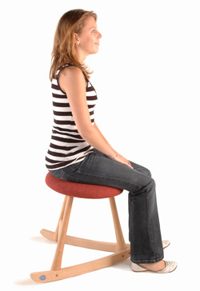

2. (a) Explain whether a water glass that tapers down to a narrow base is easier to tip over than one with straight sides. [2 marks]





(b) Discuss the difference between a full tapered glass and an empty tapered glass. You may need to use drawings to support your answer. [2 marks]



3. The irregular object shown in the figure below is hung on a string. Its centre of mass is as shown. The object rotates back and forth till it reaches a final position.

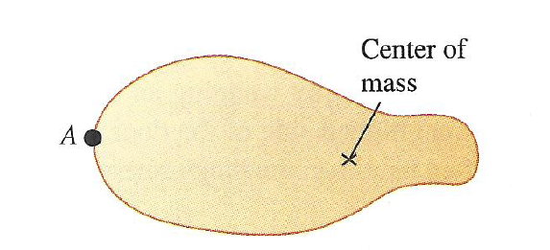

(a) Explain why the object rotates back and forth. [2 marks]

(b) Friction acts to eventually stop the object from rotating. State the position of the centre of mass in the object’s final position. [1 mark]

4. The diagram shows four forces applied to a circular object. The radius of the object is *r*. [4 marks]

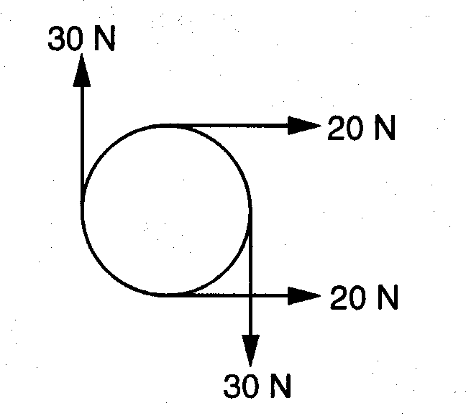

(a) Which of the following describes the resultant force and resultant torque on the object? Circle correct letter.

|  |  |  |
| --- | --- | --- |
|  | **Resultant force** | **Resultant torque** |
| **A**  **B**  **C**  **D** | zero  zero  non‑zero  non‑zero | zero  non‑zero  zero  non‑zero |

(b) Justify your answer by calculating the resultant torque (in terms of *r*) and the resultant force.

5. A globe is strung up in a classroom as shown in the diagram below. Note that the roof and T2 are both horizontal.



If the mass of the globe is 1.20 kg, determine the tension T1 and T2. The one cable is horizontal to the ground. [4 marks]

6. A uniform cantilever 5.00 m long is shown below. It has a mass of 8.00 x 102 kg and is held up by two supports **X** and **Y**.

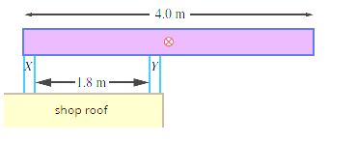

X

2.20 m

5.00 m

Y

(a) State the direction of the force exerted by support **X** on the cantilever.

[1 mark]

(b) Determine the force that each of the supports exerts on the cantilever.

[4 marks]

7. Sumo wrestling is a sport with a simple objective: push your opponent so they topple over. The Sumo wrestler is often a very large person with a lot of weight. When they begin, the wrestlers move their feet apart on the floor and crouch down low to the floor.

(a) Explain why Sumo wrestlers stand in this way. [2 marks]

(b) A 1.80 x 102 kg Sumo wrestler goes to sit 10.0 cm from the left end of a 2.50 m long bench. The bench has a mass of 4.50 kg.

(i) How far from the other end of the bench should an 80.0 kg spectator sit to just stop the bench from tipping, if the legs of the bench are 60.0 cm from each end?

Draw and label all forces and measurements on the diagram below.

[6 marks]



**Q**

**P**

(ii) Each leg of the bench can only withstand a maximum force of 2.50 x 103 N. Will the bench break with the Sumo wrestler and the spectator seated as above? Show your working out. [3 marks]

8. The diagram below shows a side view of a laptop computer resting on an outdoor table. The mass of the base of the laptop is 1.50 kg and the mass of the screen is 0.600 kg. They are both 22.0 cm long. There is an angle of 70.0° between the horizontal and the screen. The computer is blown over by wind.

Assume that the base and screen both have a uniform mass distribution.

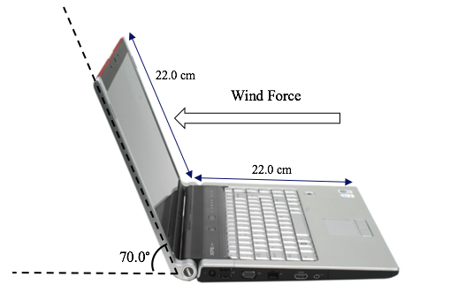

Calculate the minimum single equivalent wind force on the centre of the screen needed to tip the laptop over. [4 marks]

9. A ball is placed on different surfaces as shown in the diagrams below.

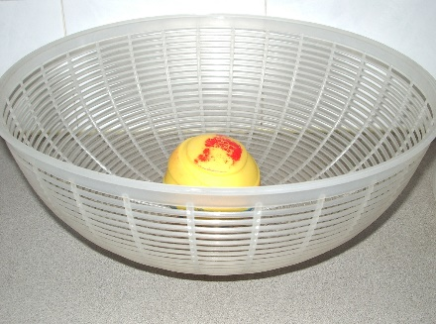 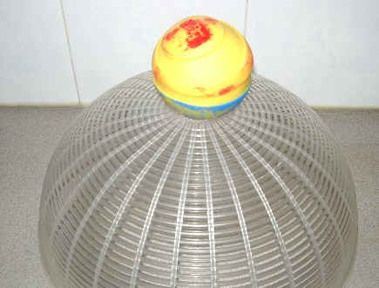 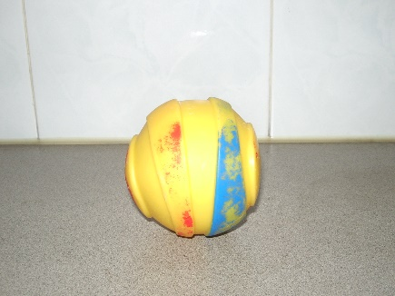

**Fig. a Fig. b Fig. c**

State whether the ball is in a state of stable equilibrium, unstable equilibrium or neutral equilibrium and explain your answer in each case. [3 marks]

Fig. a:

Fig. b:

Fig. c:

10. A decorative mobile contains three unknown weights A, B and C. The strings and rods have negligible weight and the rods are to hang horizontally. Find the weights of the balls A, B and C. [4 marks]

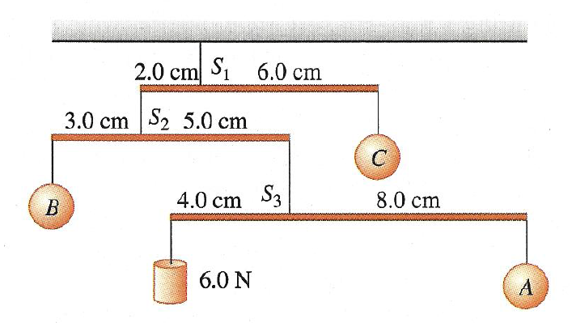

11. A person climbs a ladder that leans on wall as shown below.

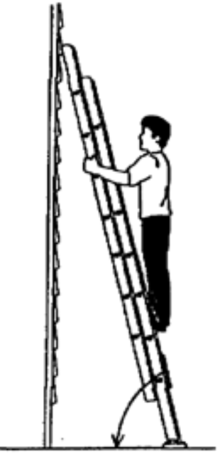

**A**

The ladder is 3.00 m long and rests at a distance of 1.80 m away from a wall. The man stands with his feet 0.500 m above the ground. The ladder has a negligible mass and the man has a mass of 75.0 kg.

(a) Determine the angle the ladder makes with the ground. [1 mark]

(b) Calculate the force that the wall exerts on the ladder at position **A**. Assume that the force acts at right angles to the wall. [6 marks]

(c) If the person climbs higher up the ladder, explain qualitatively how the force exerted on the ladder by the wall changes. [3 marks]